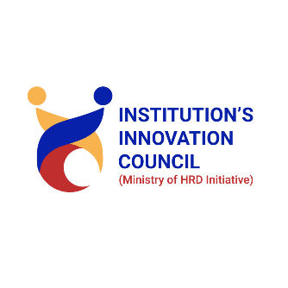
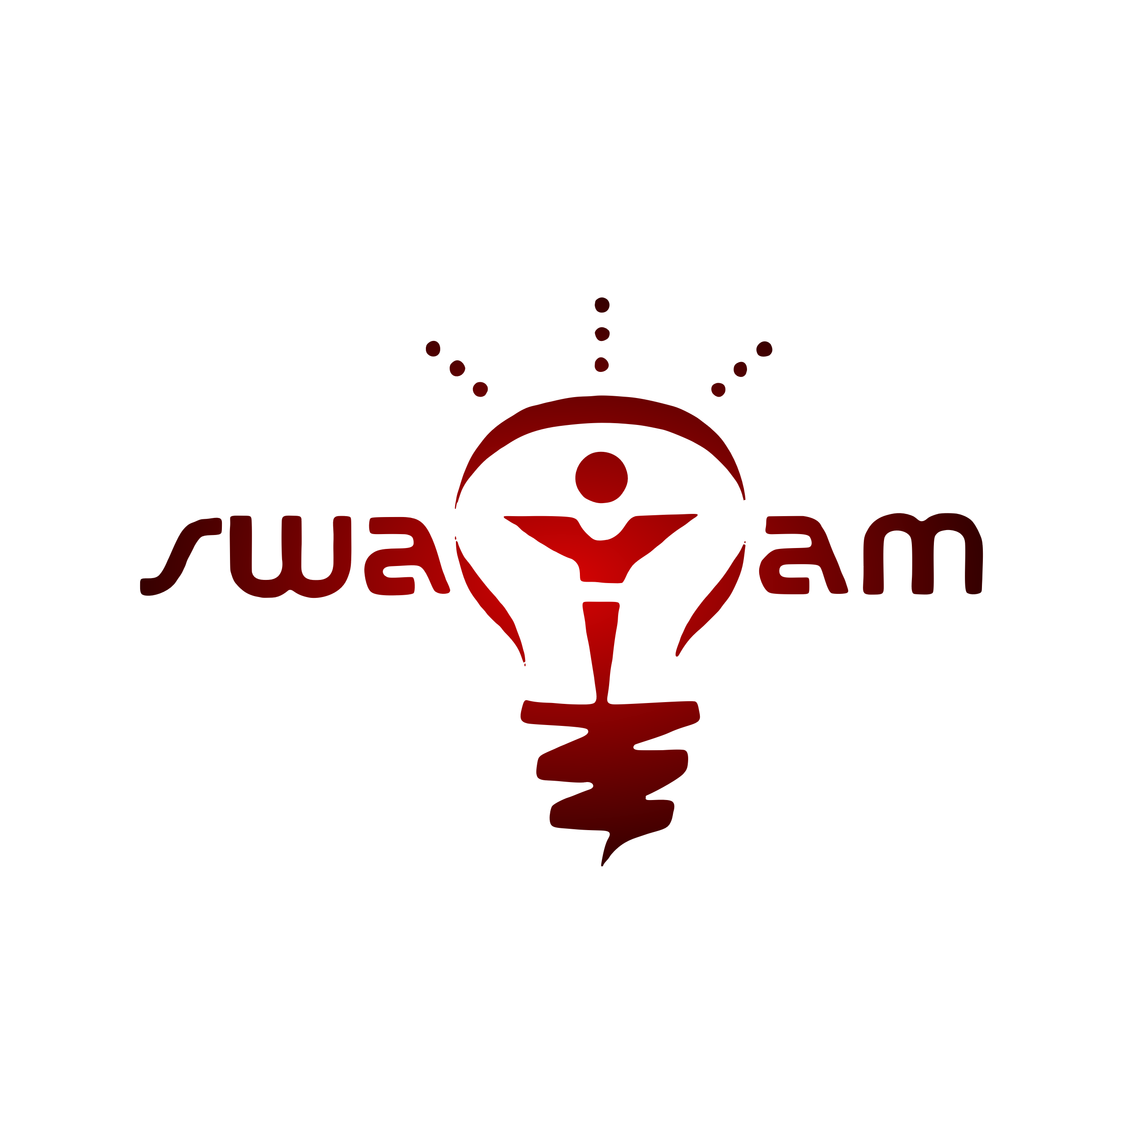
Vasavi College of Engineering (A)
Accredited by NAAC with ‘A++’ Grade.
Ibrahimbagh, Hyderabad-500031, Telangana.
Swayam – Entrepreneurship Development Cell

E-Summit 2026
Date : 10/04/2026 & 11/04/2026

Venue : Vasavi College of Engineering, Ibrahimbagh, Hyderabad

Duration (in Hours) : 2 Days (Approx. 16 Hours)

Resource Person/Speaker/Guest (if any) : Viveck Verma (Upsurge), Puru Modani (BM Capital Family Office), Vishal Reddy (Entrepreneurology), Shahar Banu (DevOps Specialist), Vamshi Krishna Reddy, Krishna Chaitanya Reddy, Abhiram Sreekar (ServiceNow), Shilpa Joshi (Deloitte), Kaushal Attaluri (Pegasystems)

Mode of Session : Offline

Event Objectives :

- To nurture entrepreneurial thinking and business acumen among students
- To provide hands-on learning through competitions, simulations, and workshops
- To connect students with innovators, founders, and industry professionals
- To expose participants to real-world business challenges and startup culture

Event Description / Flow of Event :

- E-Summit 2026 was the annual entrepreneurship festival of Swayam – ED Cell, held across two days. The summit created a vibrant platform combining keynote talks, interactive workshops, and competitive events. Day 1 (10th April) featured the inaugural ceremony, an E-Talk by Viveck Verma (Founder & CEO, Upsurge), the Business Debate Challenge, Ideation x Shark Tank with investor panelists, and IPL Auction Ideation. Day 2 (11th April) focused on skill-building through a GitHub Masterclass by Shahar Banu (DevOps Specialist), an Idea Under Fire pitching challenge, a Content Creation Talk by Vamshi Krishna Reddy and Krishna Chaitanya Reddy, the Smart Campus Hackathon mentored by professionals from ServiceNow, Deloitte, and Pegasystems, and Pitch Play Profit 2.0.

Activities Conducted :

S.No. | Activity Name | Description
1 | E-Talk & Business Debate Challenge | Keynote by Viveck Verma (Founder & CEO, Upsurge) encouraging bold entrepreneurial thinking; followed by team debates on rival brands testing analytical and persuasive communication skills.
2 | Ideation x Shark Tank & IPL Auction Ideation | Participants pitched innovative ideas to panelists Puru Modani (BM Capital) and Vishal Reddy (Entrepreneurology) for investor-level feedback; IPL Auction Ideation tested resource allocation and strategic decision-making.
3 | GitHub Masterclass & Idea Under Fire | Hands-on Git & GitHub training by Shahar Banu (DevOps Specialist) on collaborative development tools; rapid-fire pitching challenge testing spontaneity and confidence under pressure.
4 | Smart Campus Hackathon | Participants developed innovative solutions to campus challenges under mentorship from Abhiram Sreekar (ServiceNow), Shilpa Joshi (Deloitte), and Kaushal Attaluri (Pegasystems).
5 | Content Creation Talk & Pitch Play Profit 2.0 | Session by Vamshi Krishna Reddy and Krishna Chaitanya Reddy on storytelling and digital branding; simulation event requiring strategic planning and entrepreneurial decision-making.

Event Outcomes & Impact :

Greater entrepreneurial awareness and confidence among 100+ participants; improved problem-solving, analytical, and decision-making skills; strengthened leadership and teamwork; practical exposure to pitching, digital branding, and technical tools such as Git/GitHub; expanded networking opportunities with industry professionals and peers.

Conclusion :

E-Summit 2026 was successfully executed, achieving its objectives and delivering significant value to all 100 participants. The contributions of guest speakers and industry professionals enriched the experience, reinforcing the ED Cell’s vision of fostering entrepreneurship and innovation. The summit stands as a benchmark initiative and continuation of such programs is recommended.

Feedback & Suggestions :

(Short summary of participant feedback and suggestions for improvement.)
Participants responded positively to the summit, appreciating the diversity of activities and quality of industry engagement. The Shark Tank and Hackathon sessions were highlighted as the most impactful. Suggestions included extending the duration of individual workshops and providing pre-event reading materials. The in-house HR team is requested to collect feedback from 4–5 participants and append their responses to this report.

Expenditure Details :
Expenditure Amount : ₹1,53,447
Source of Funds : Institution (₹66,000) / Sponsorship (₹46,500) / Registration Fee (₹40,947)

Remark :

E-Summit 2026 was a well-organized two-day festival that successfully bridged academia and industry through impactful sessions and competitions.

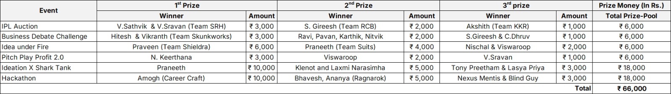
Winner Details :

Photographs & Media :

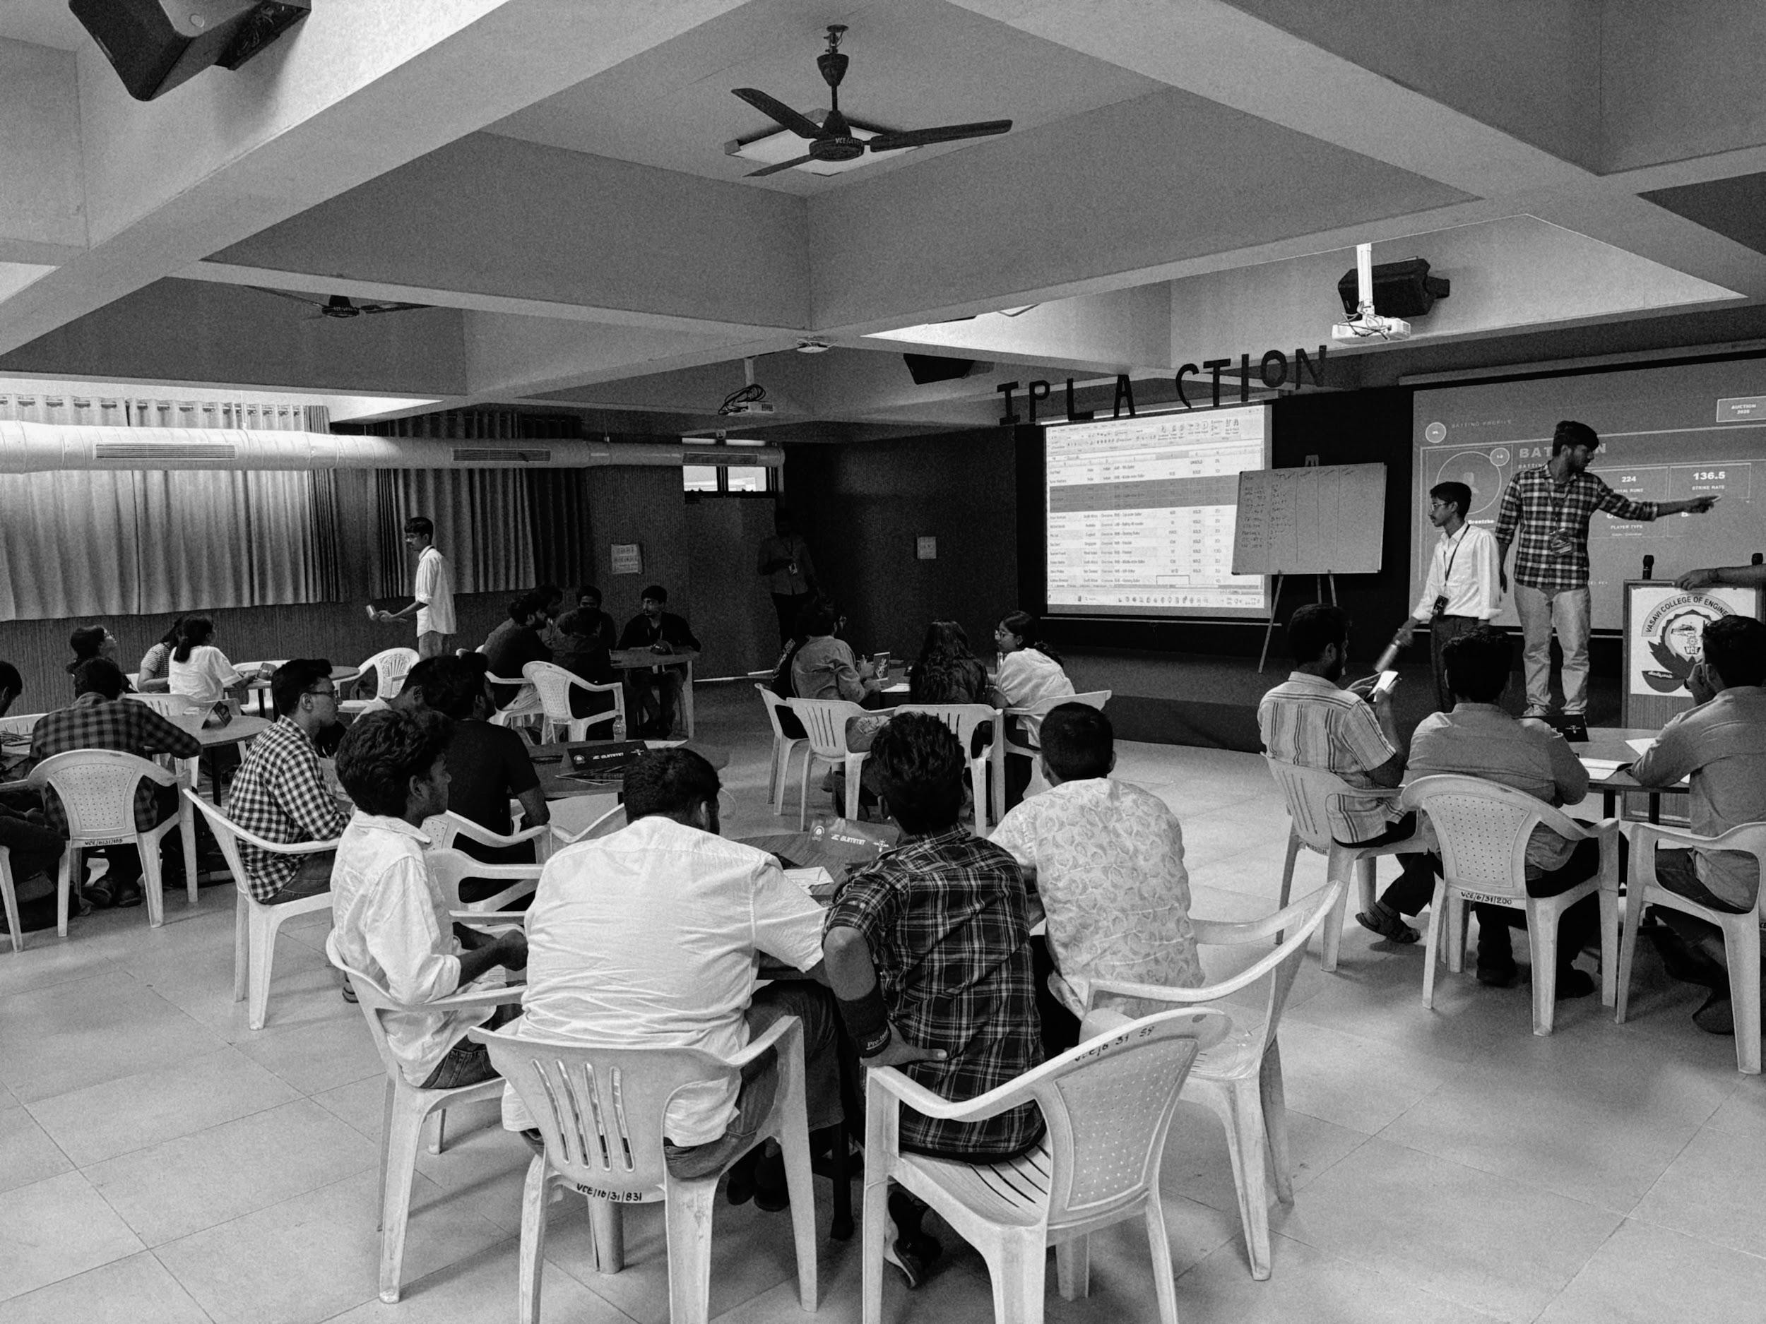
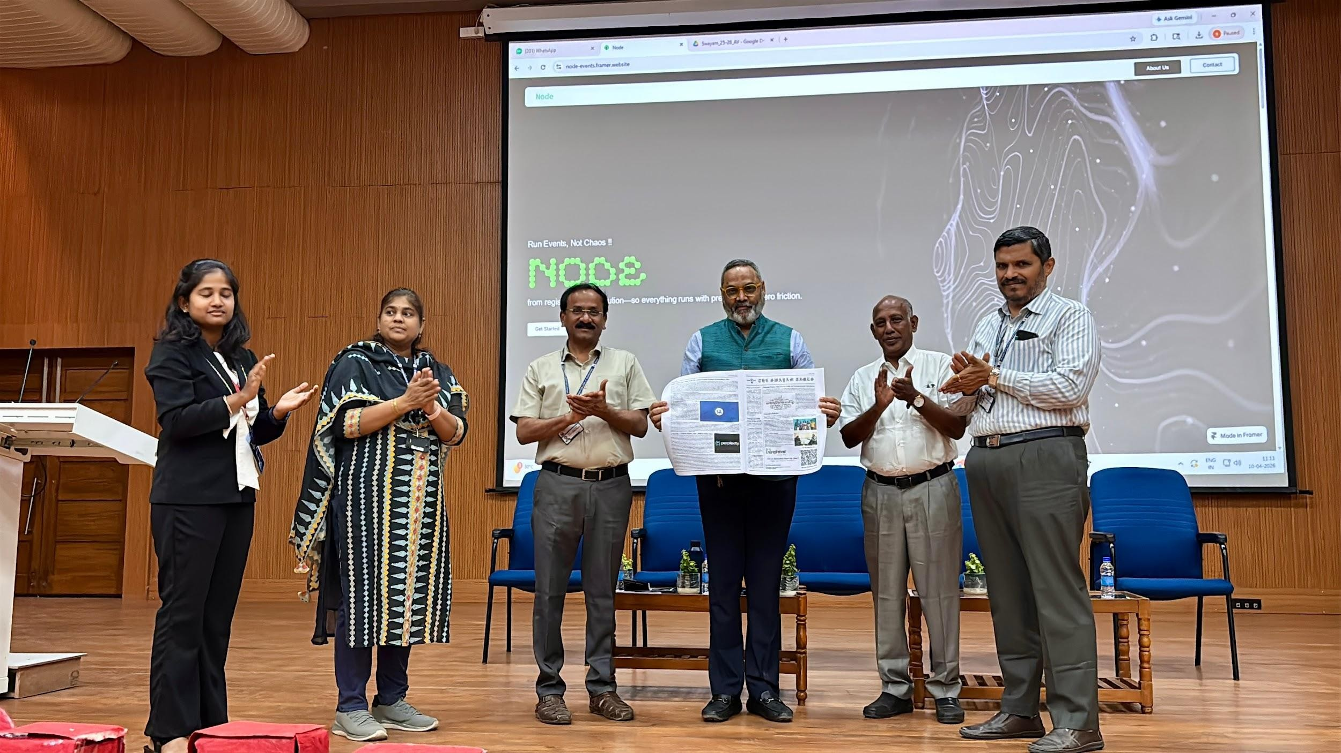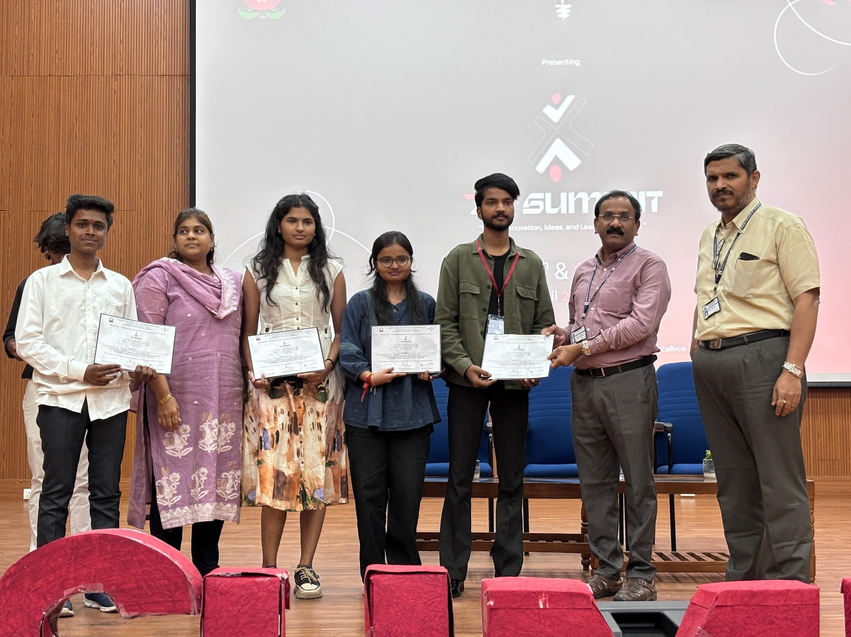
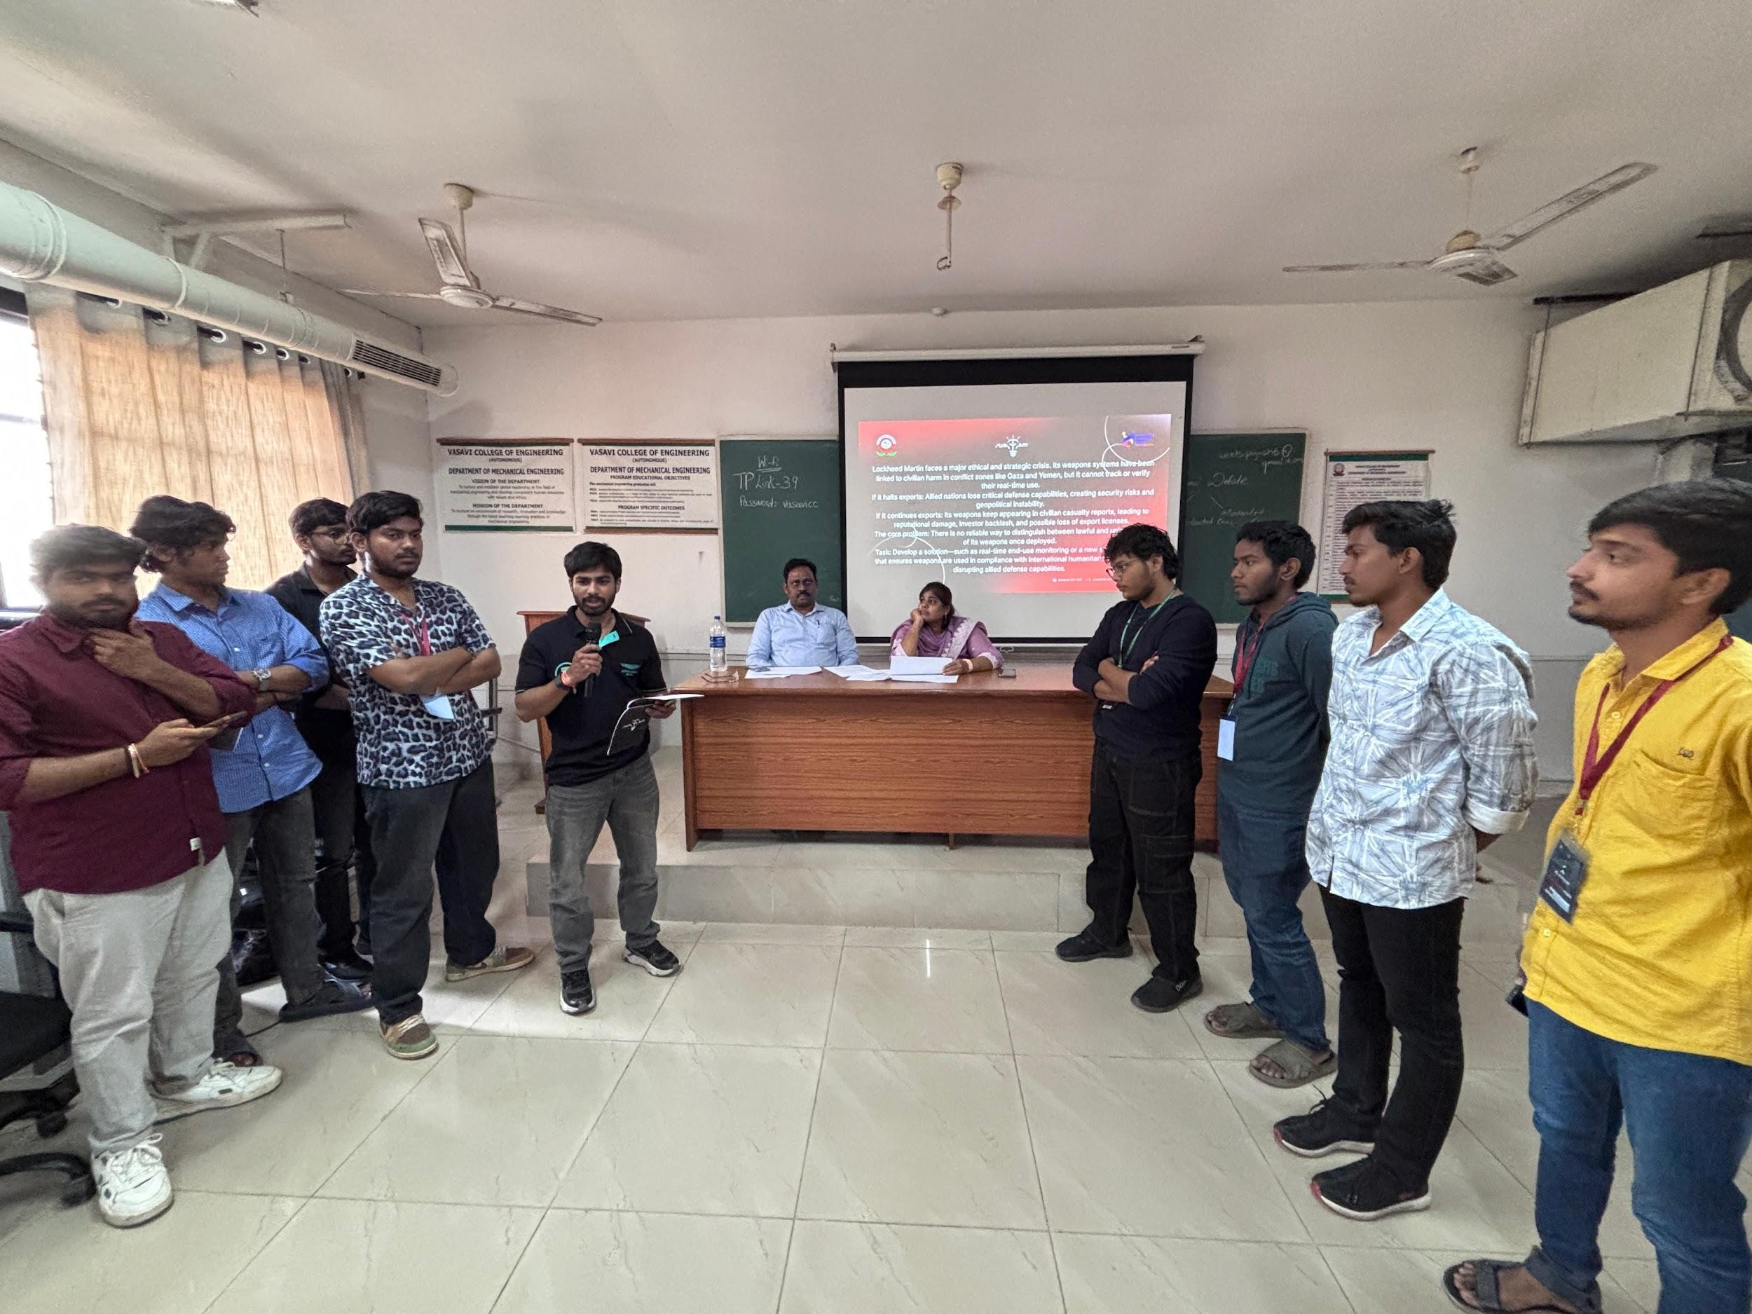
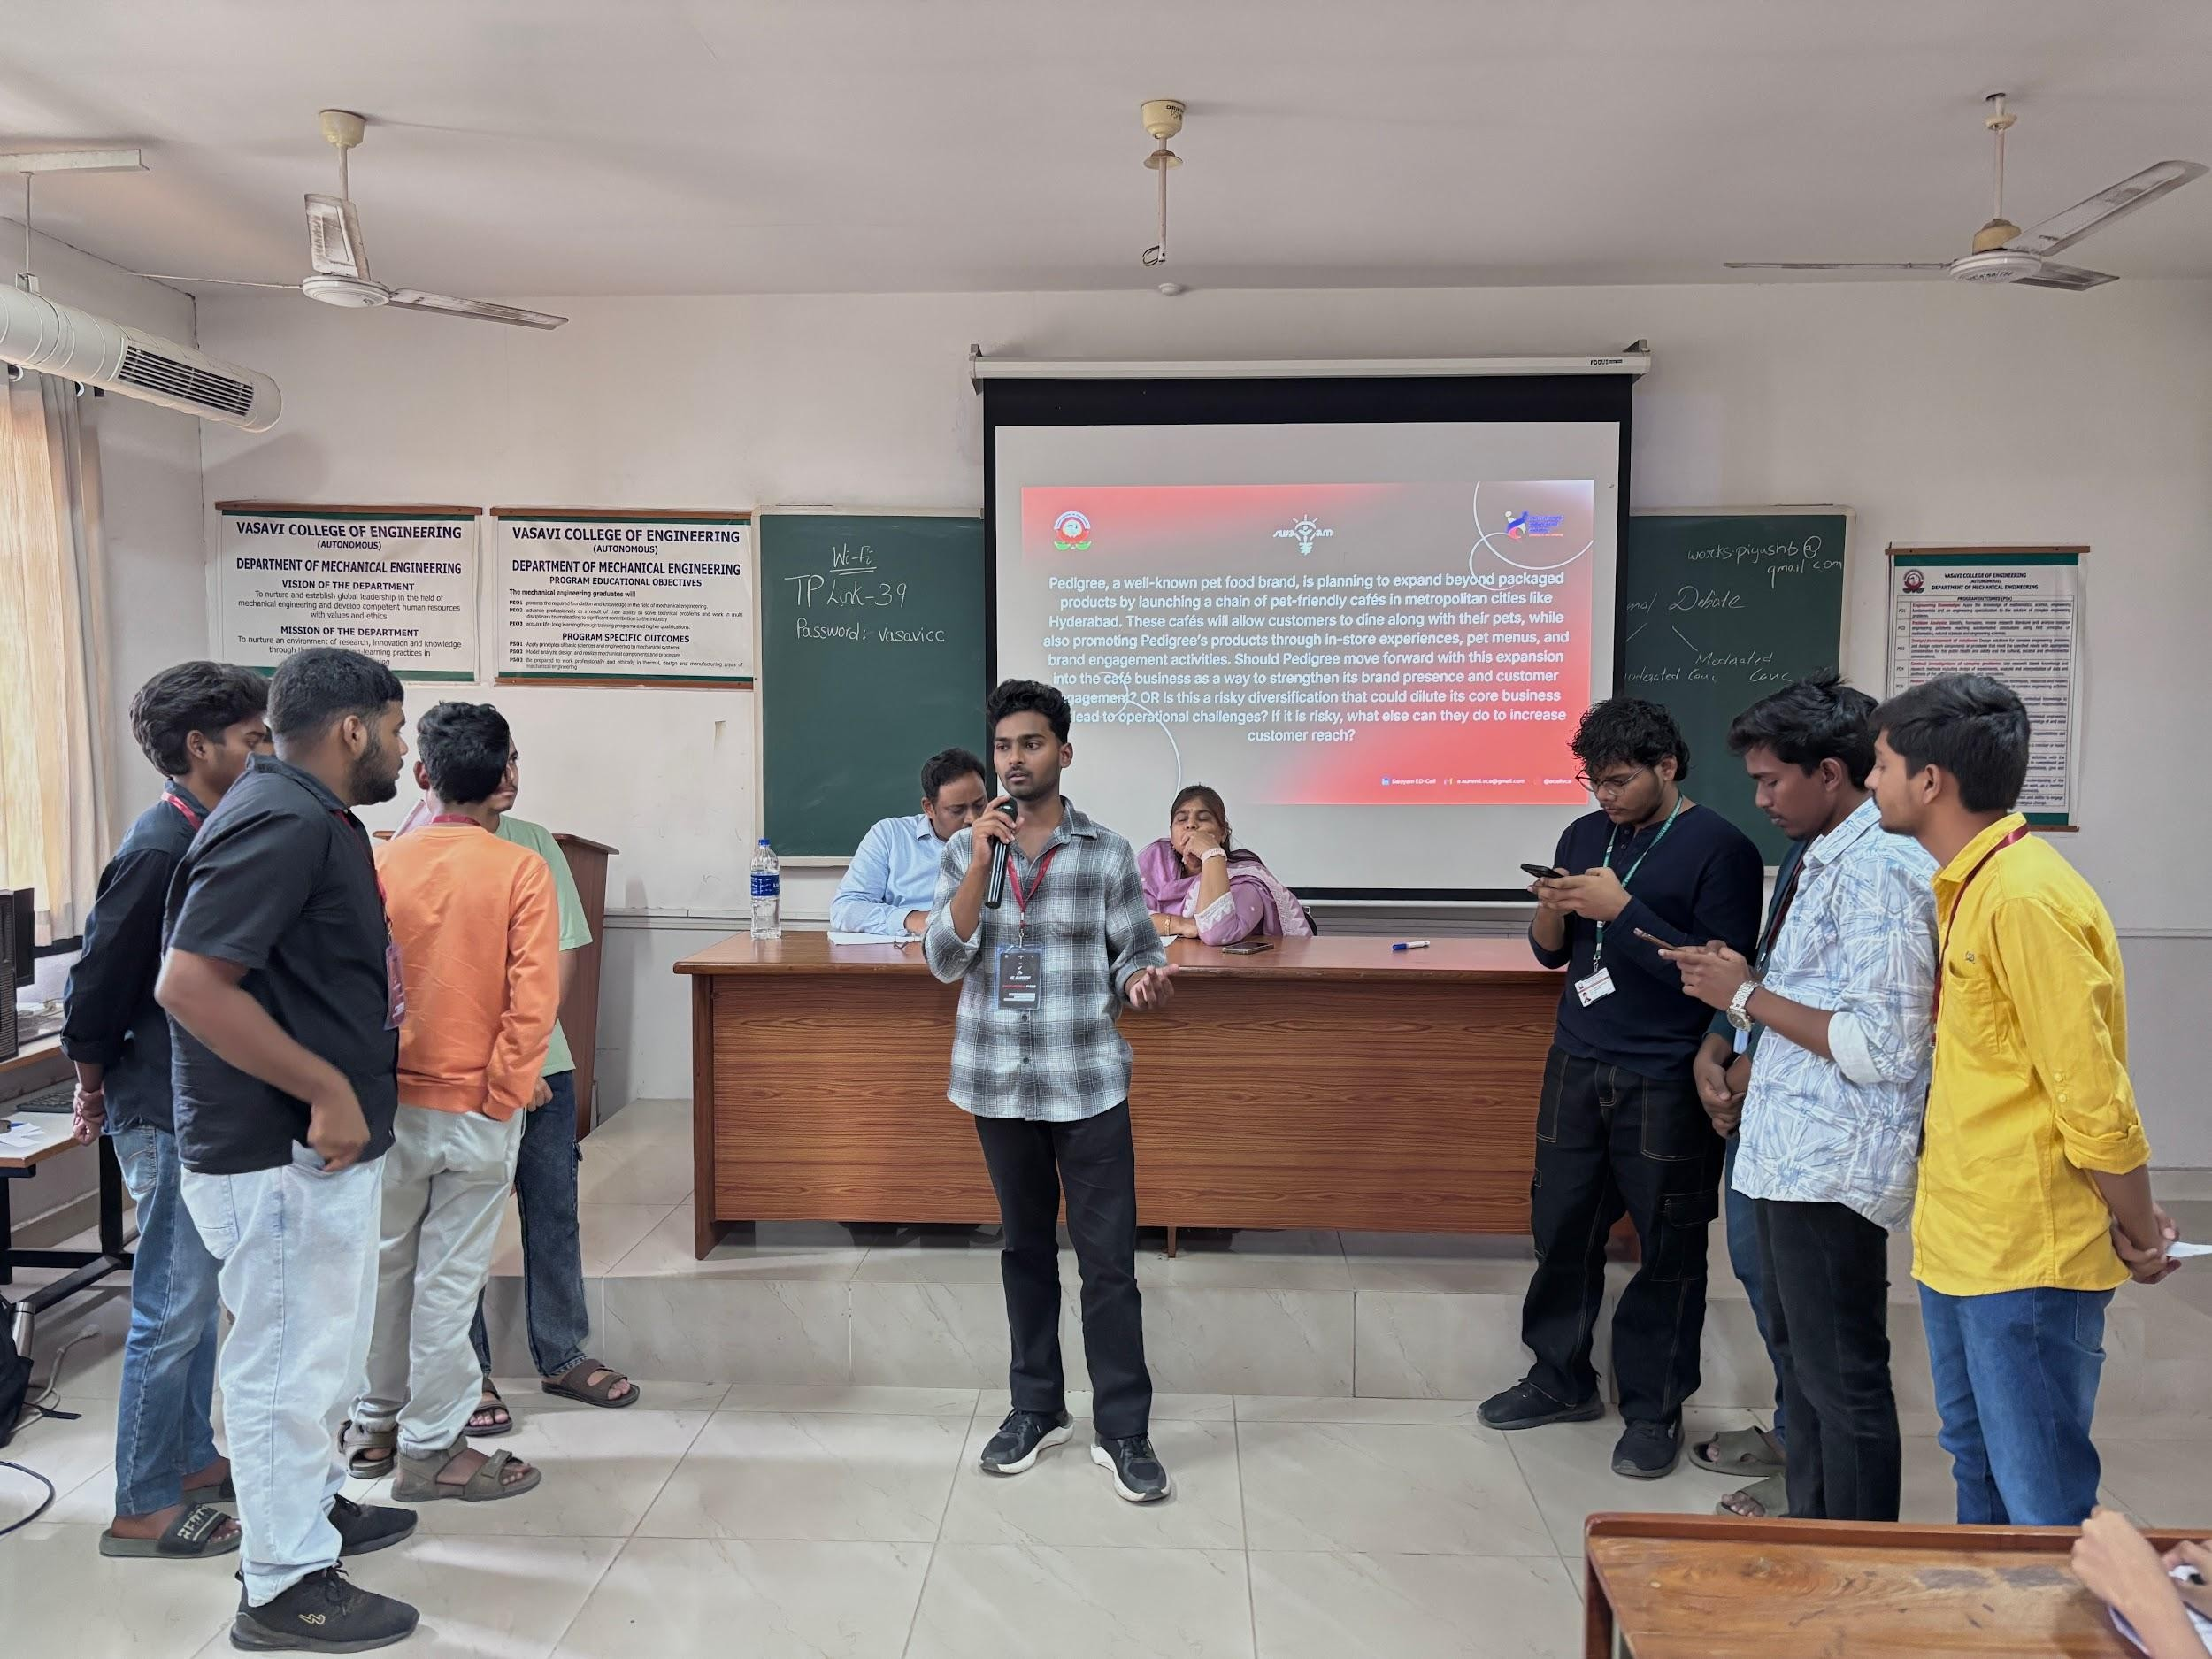

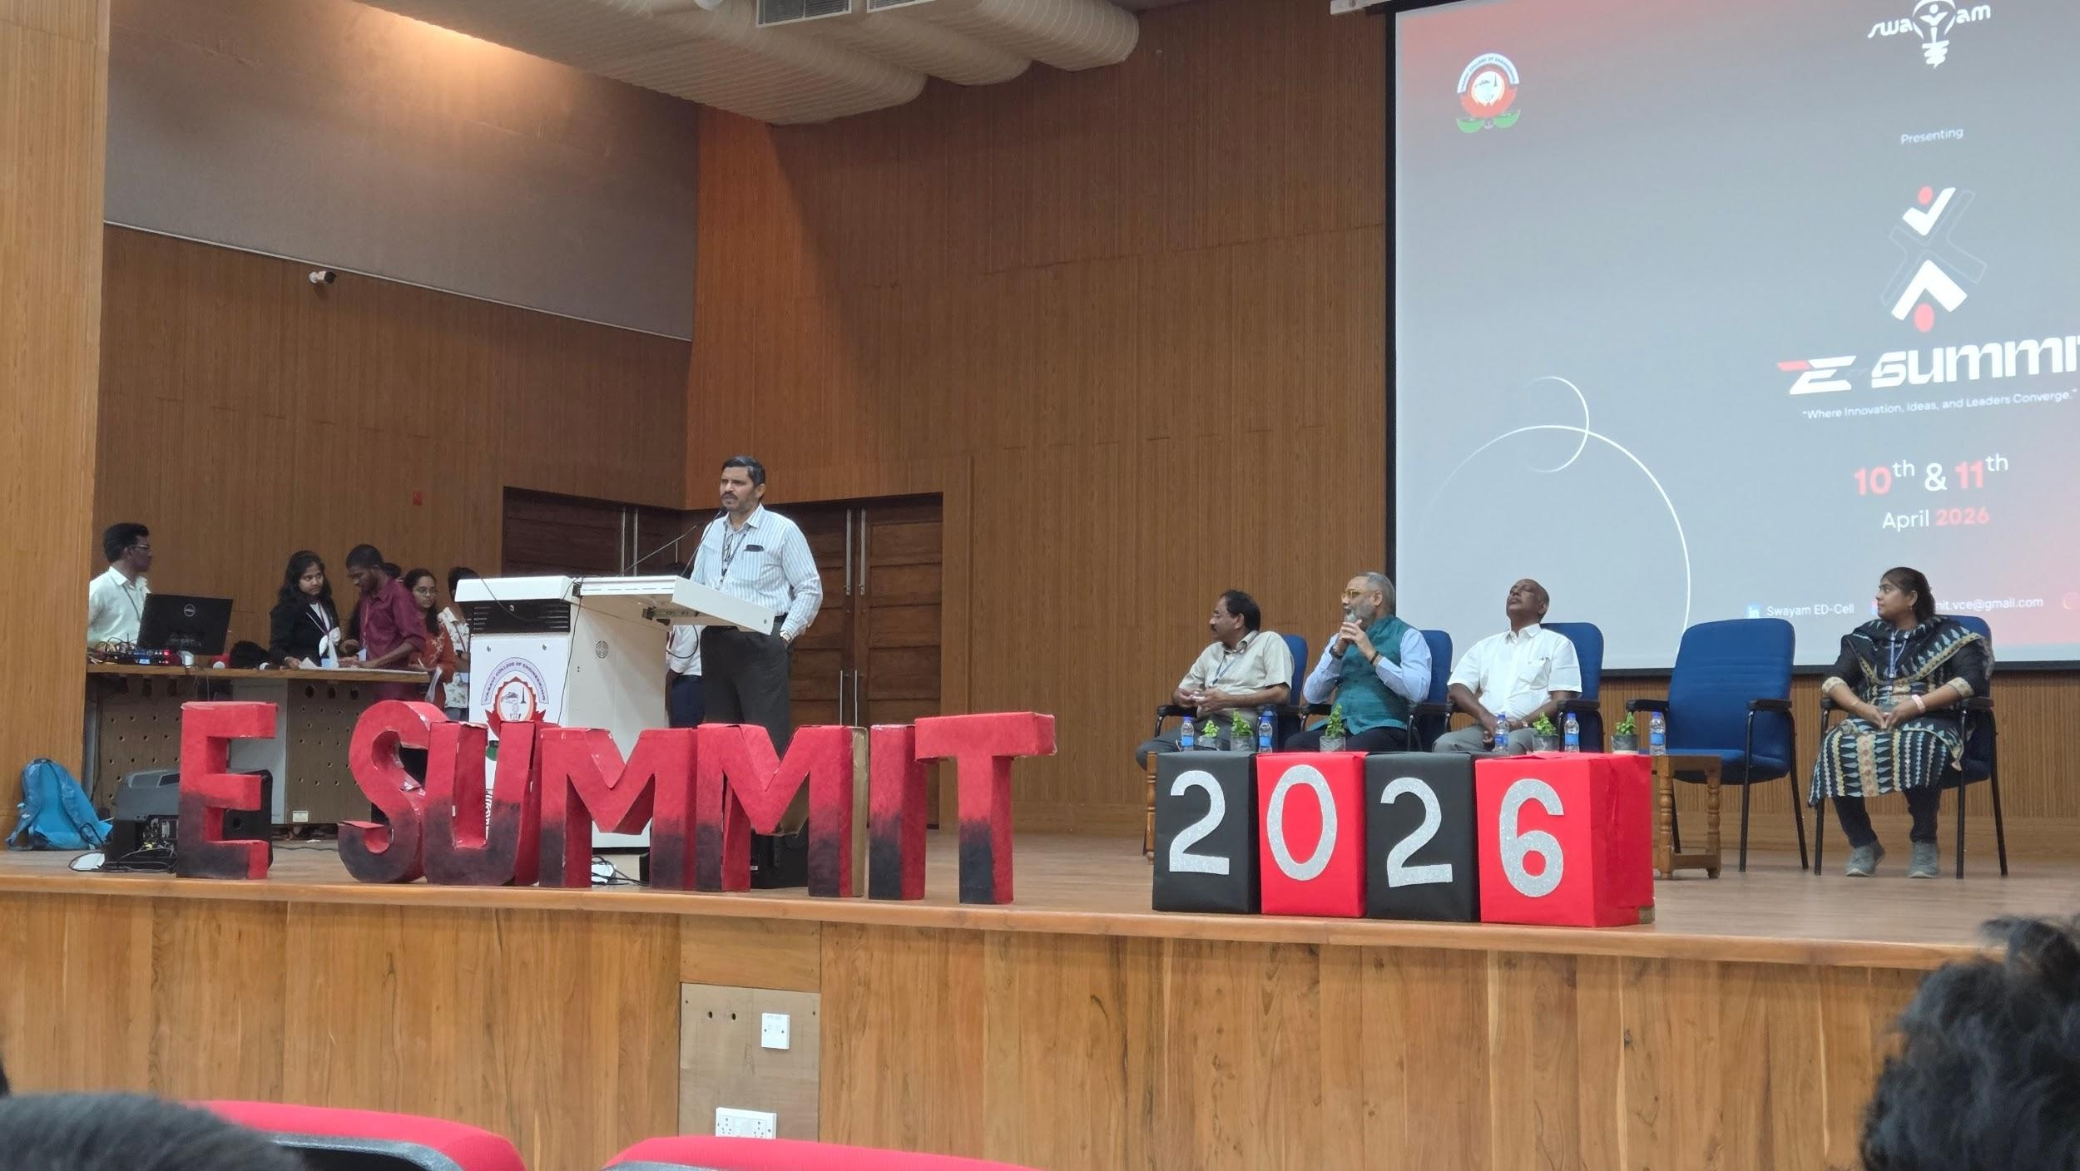
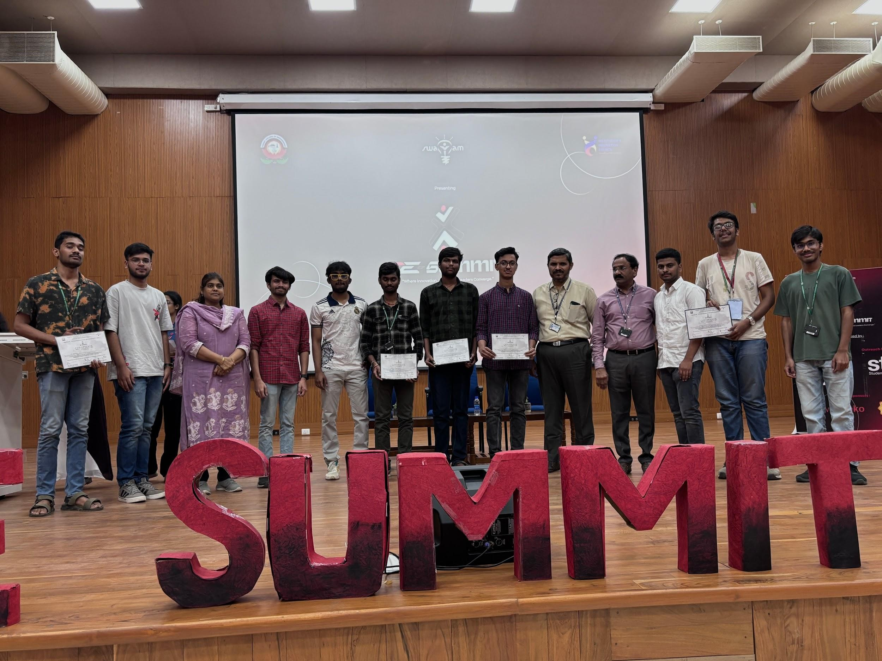
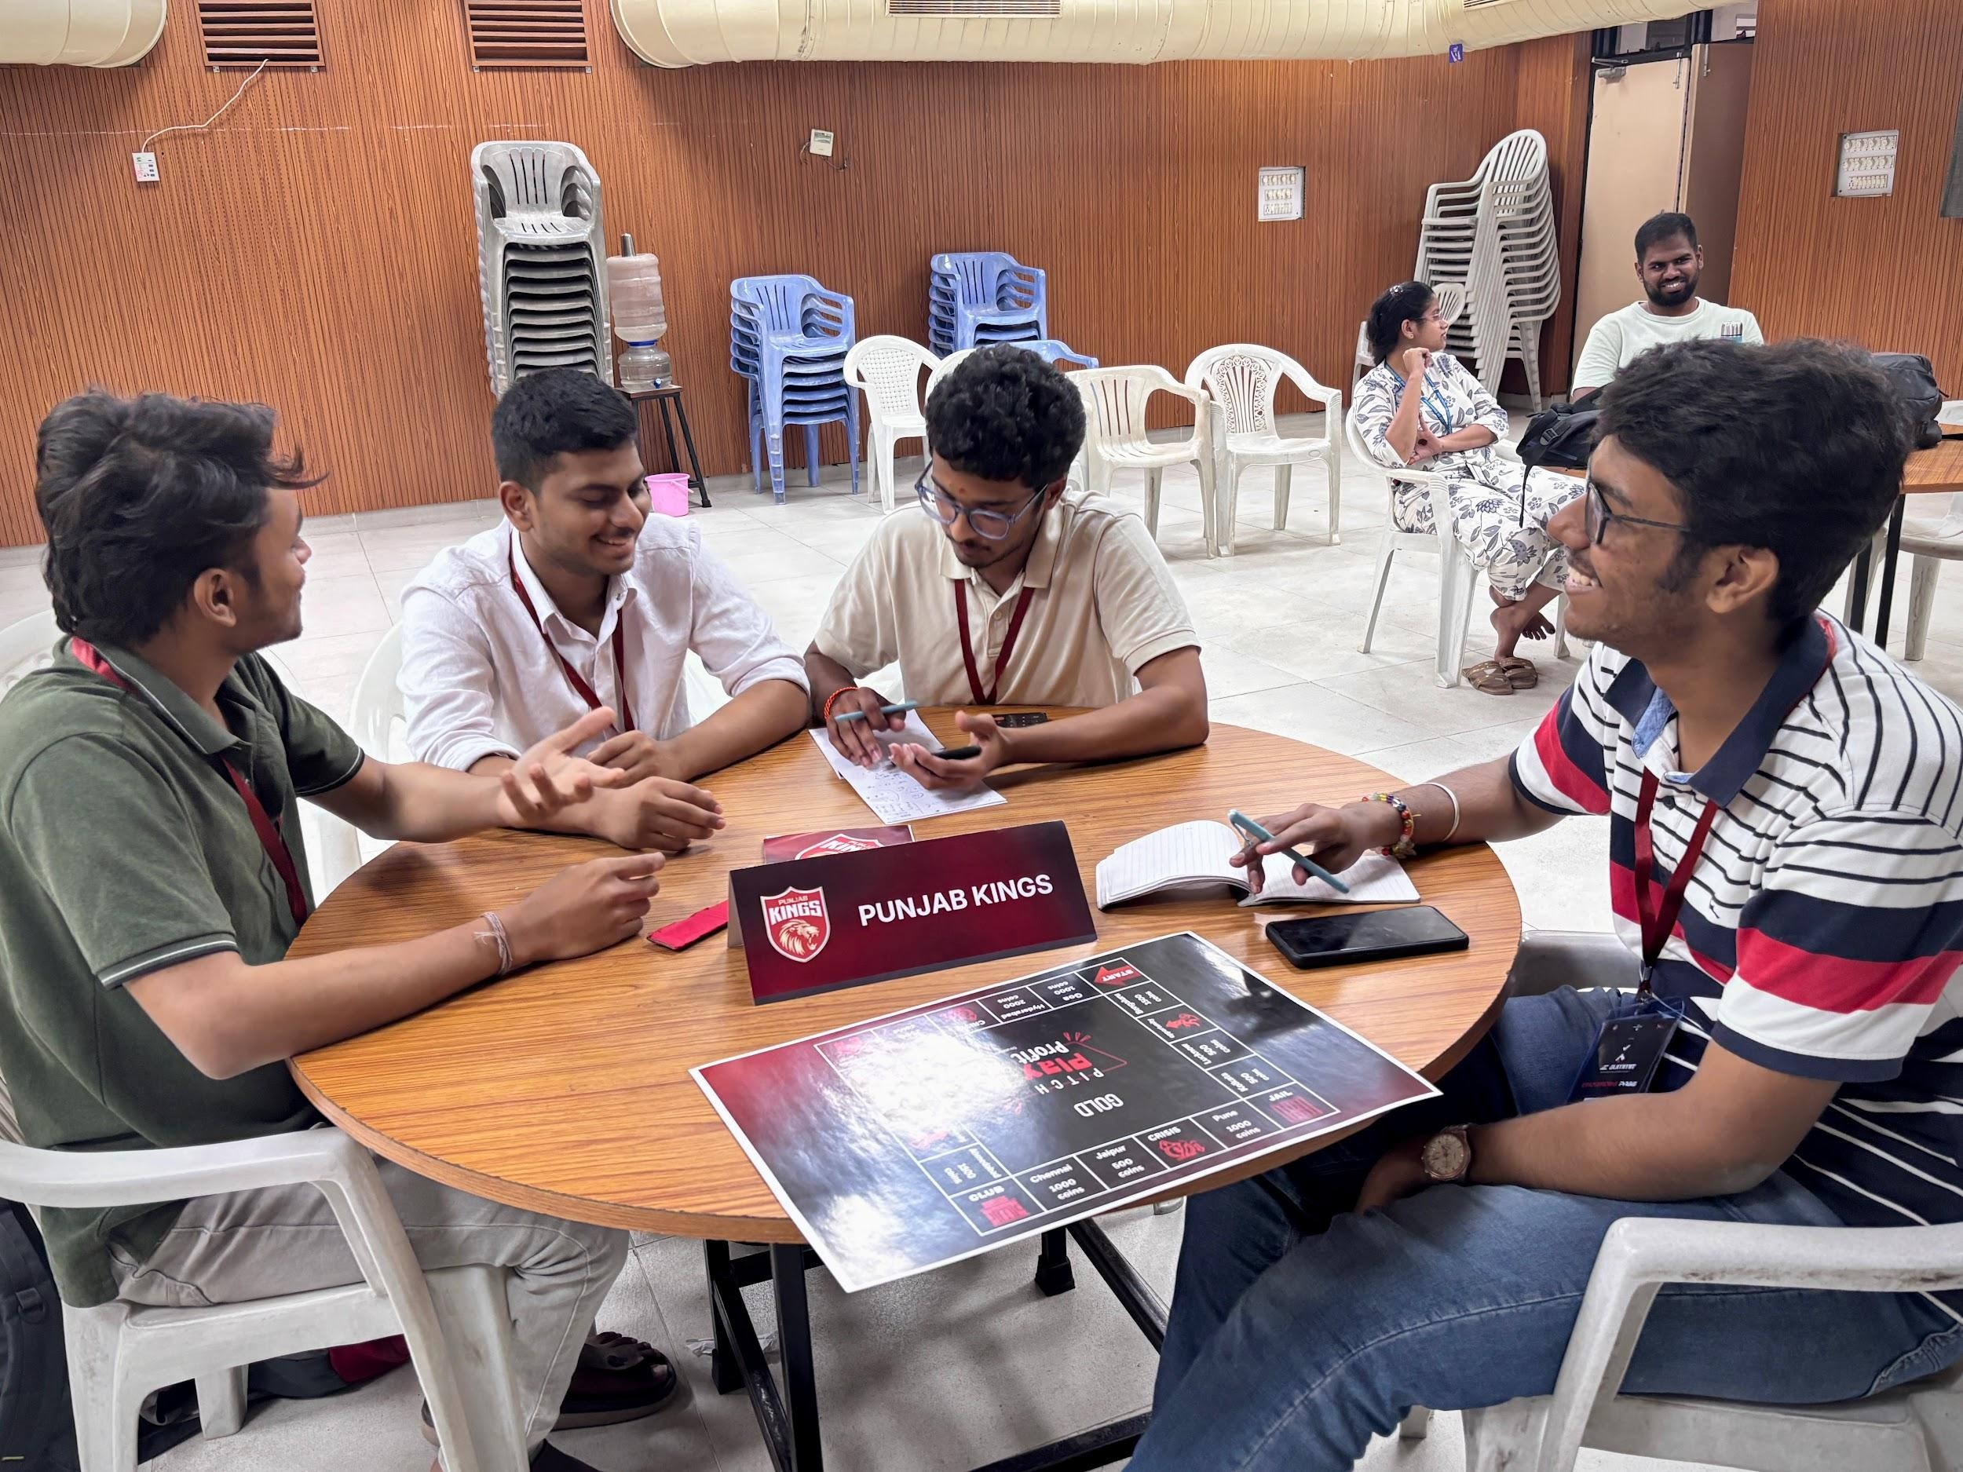
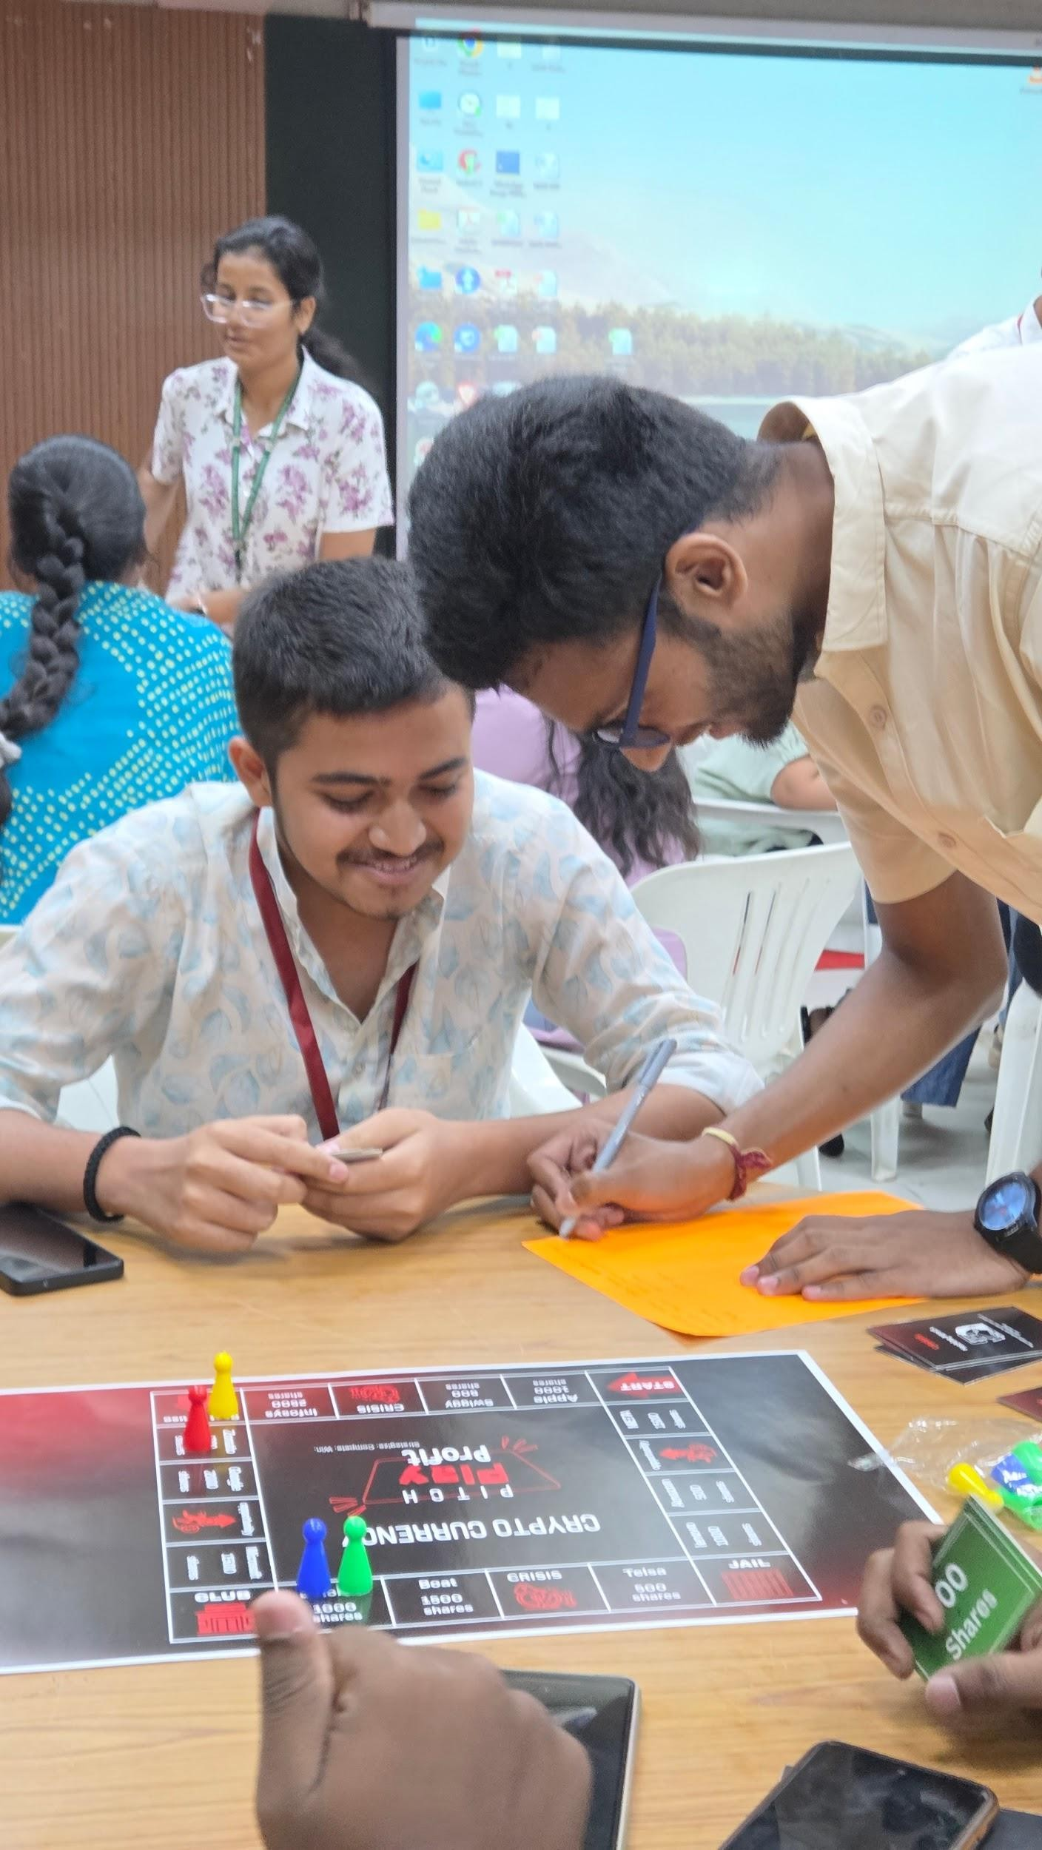
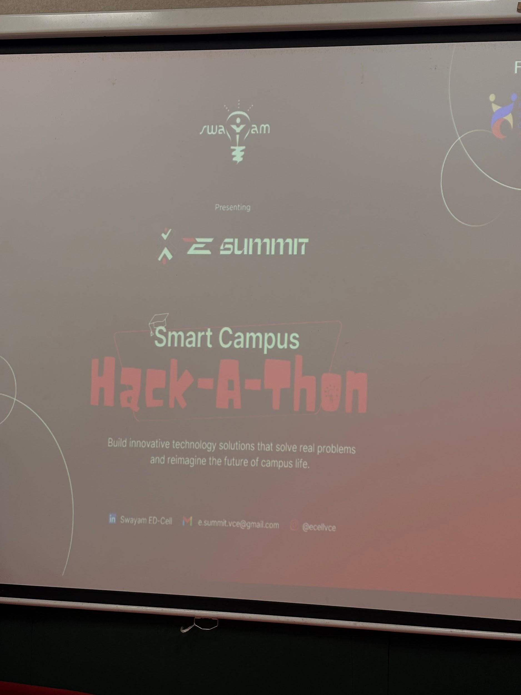
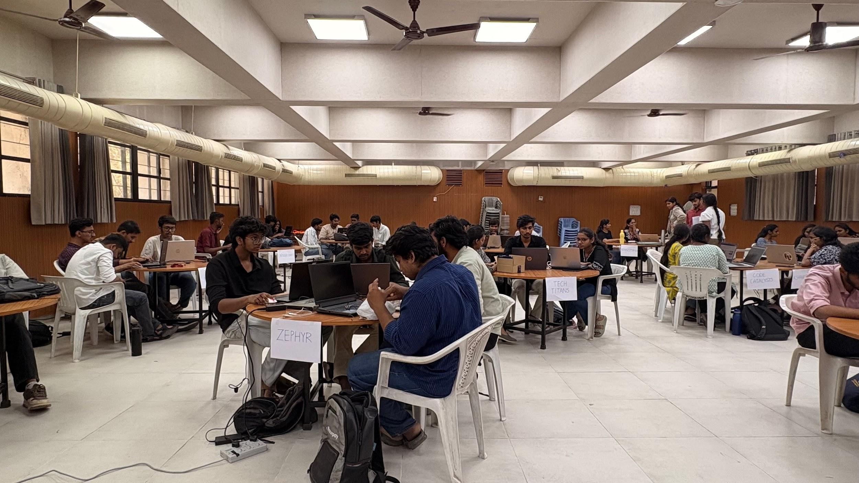
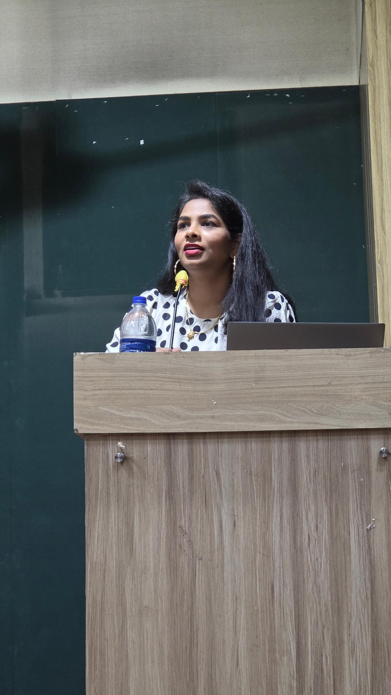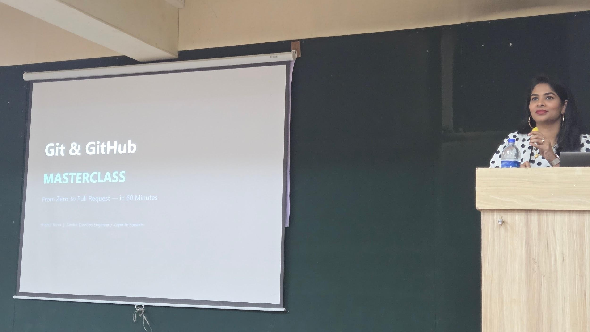

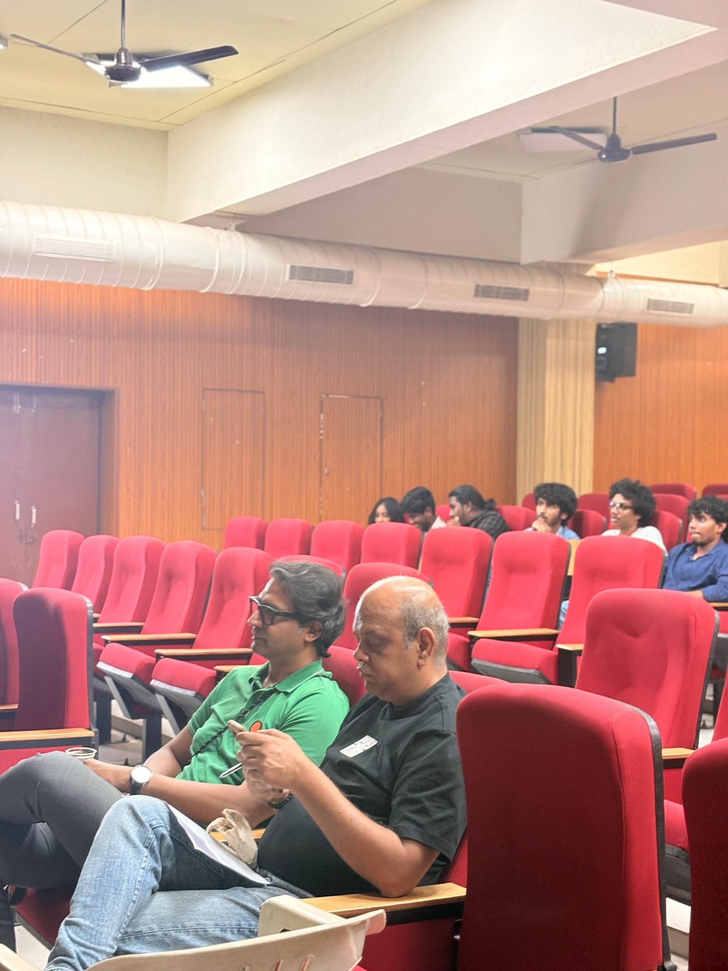
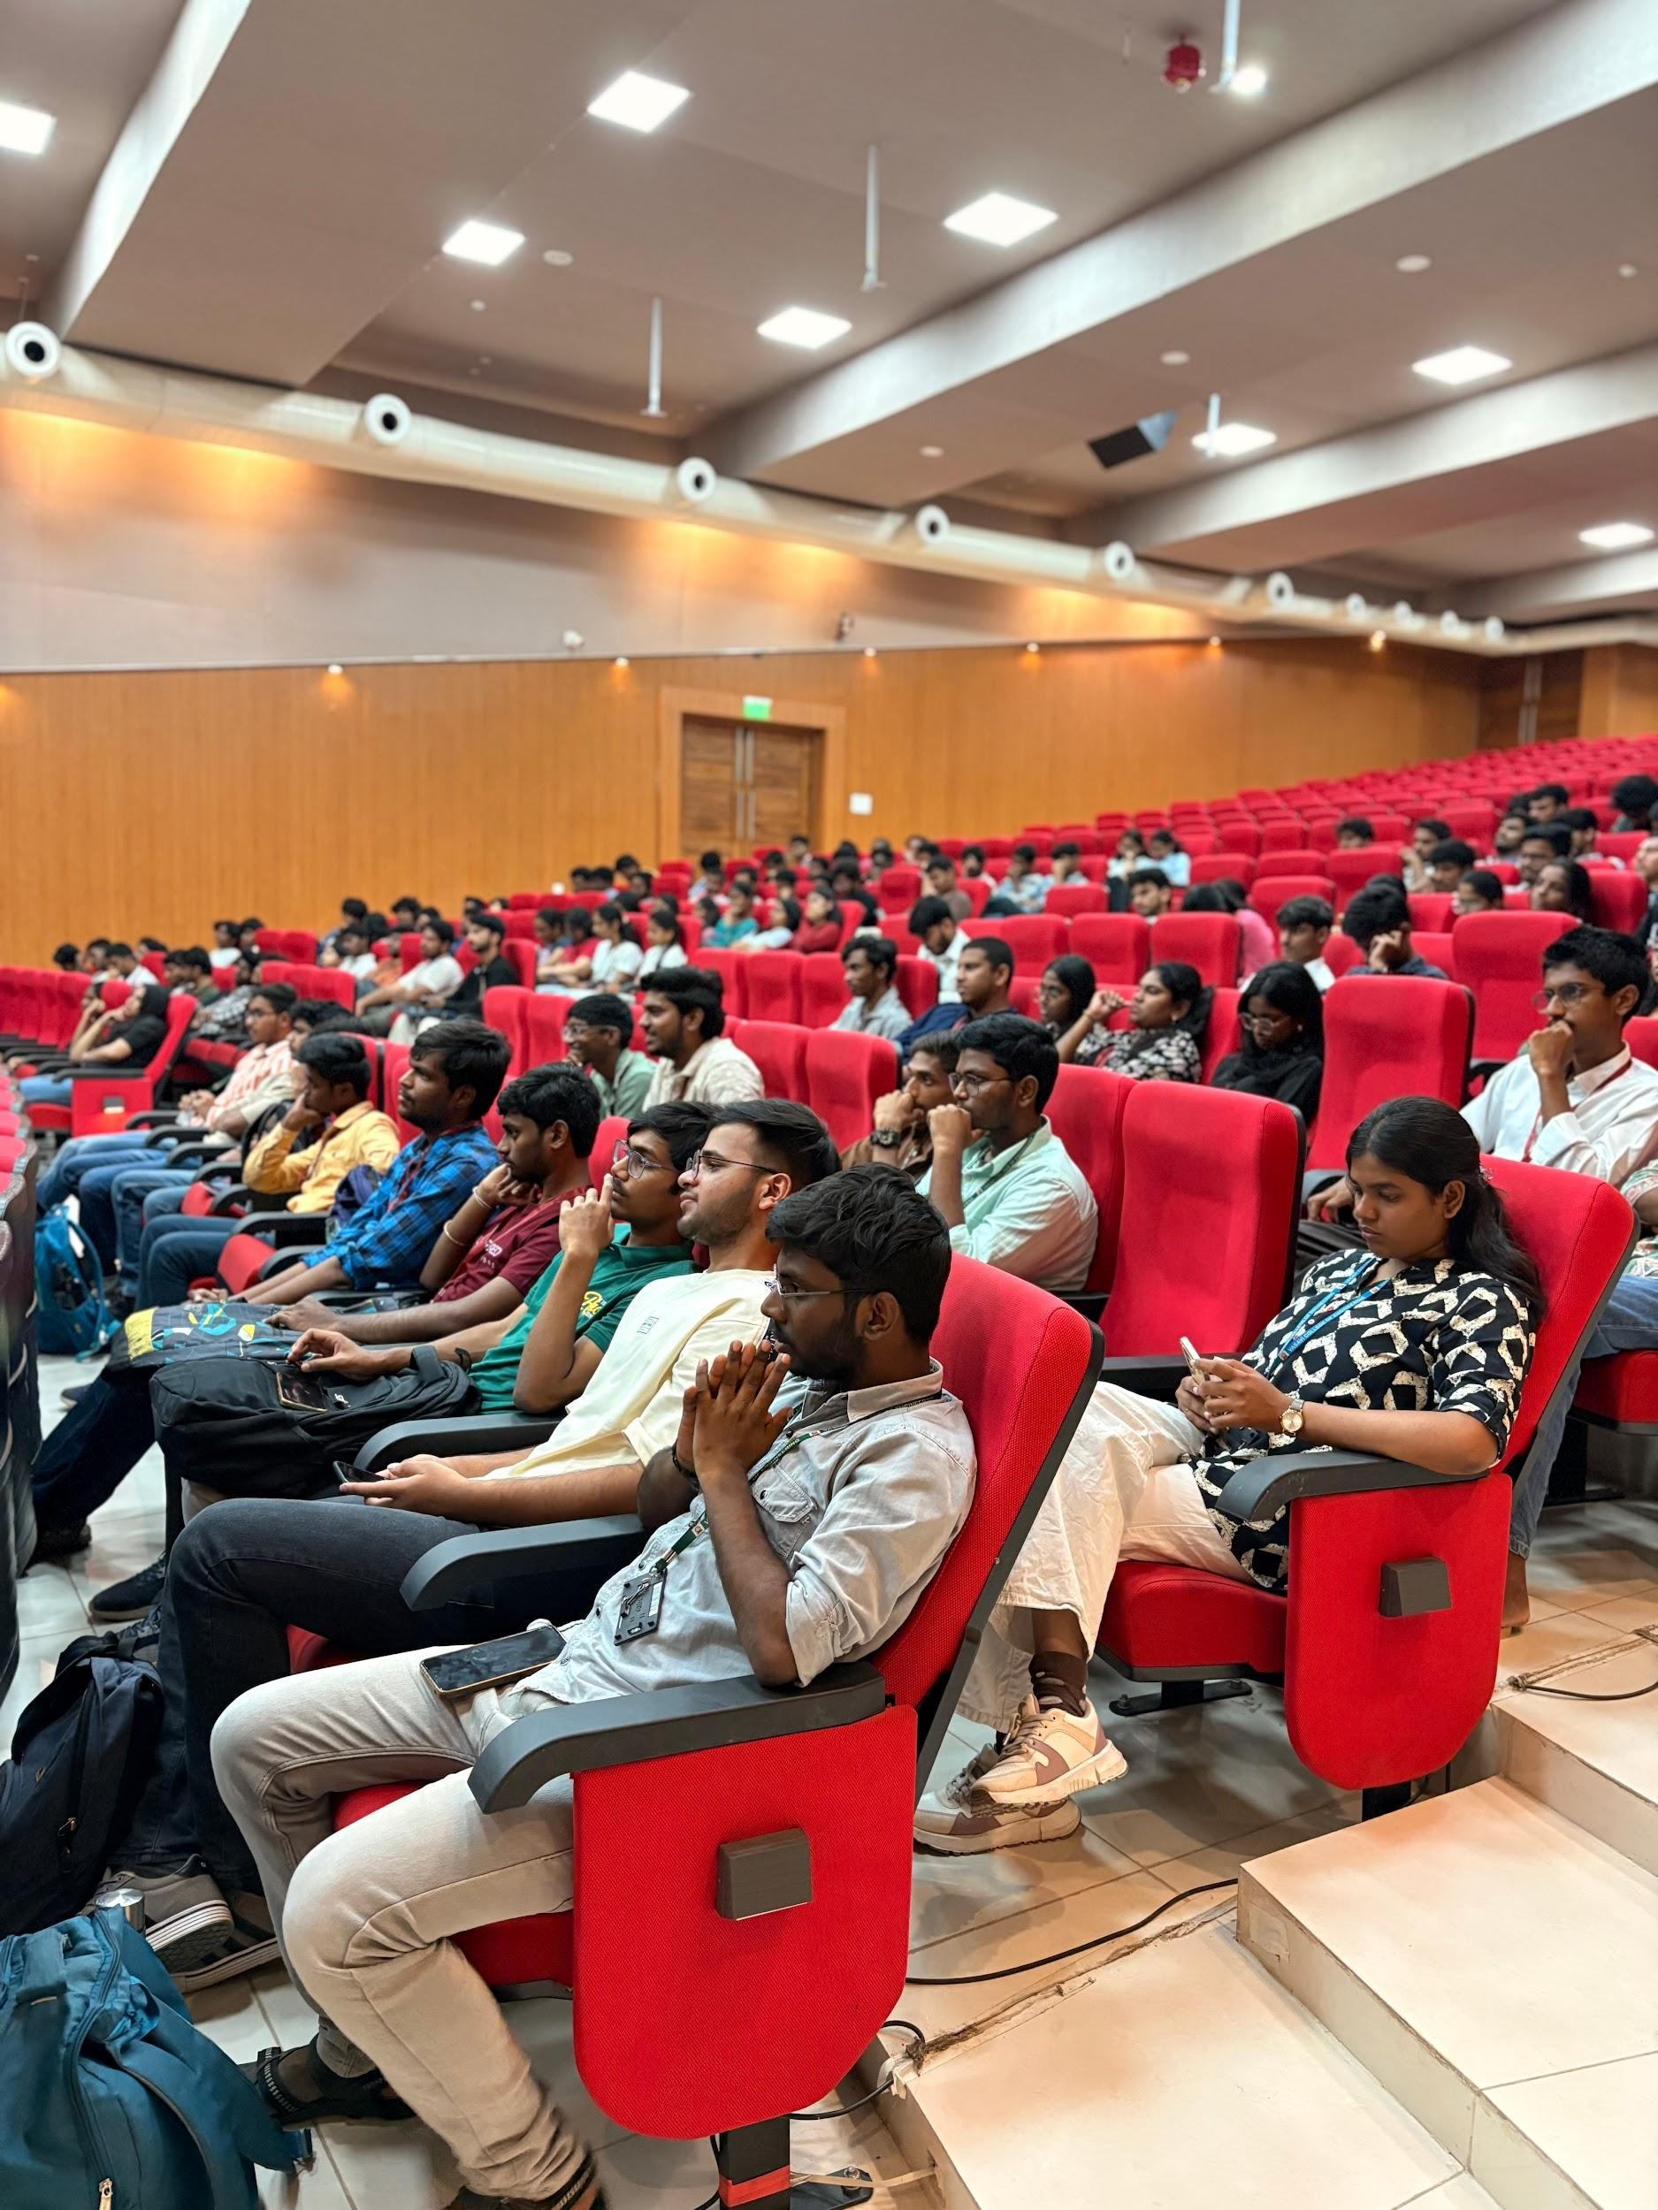
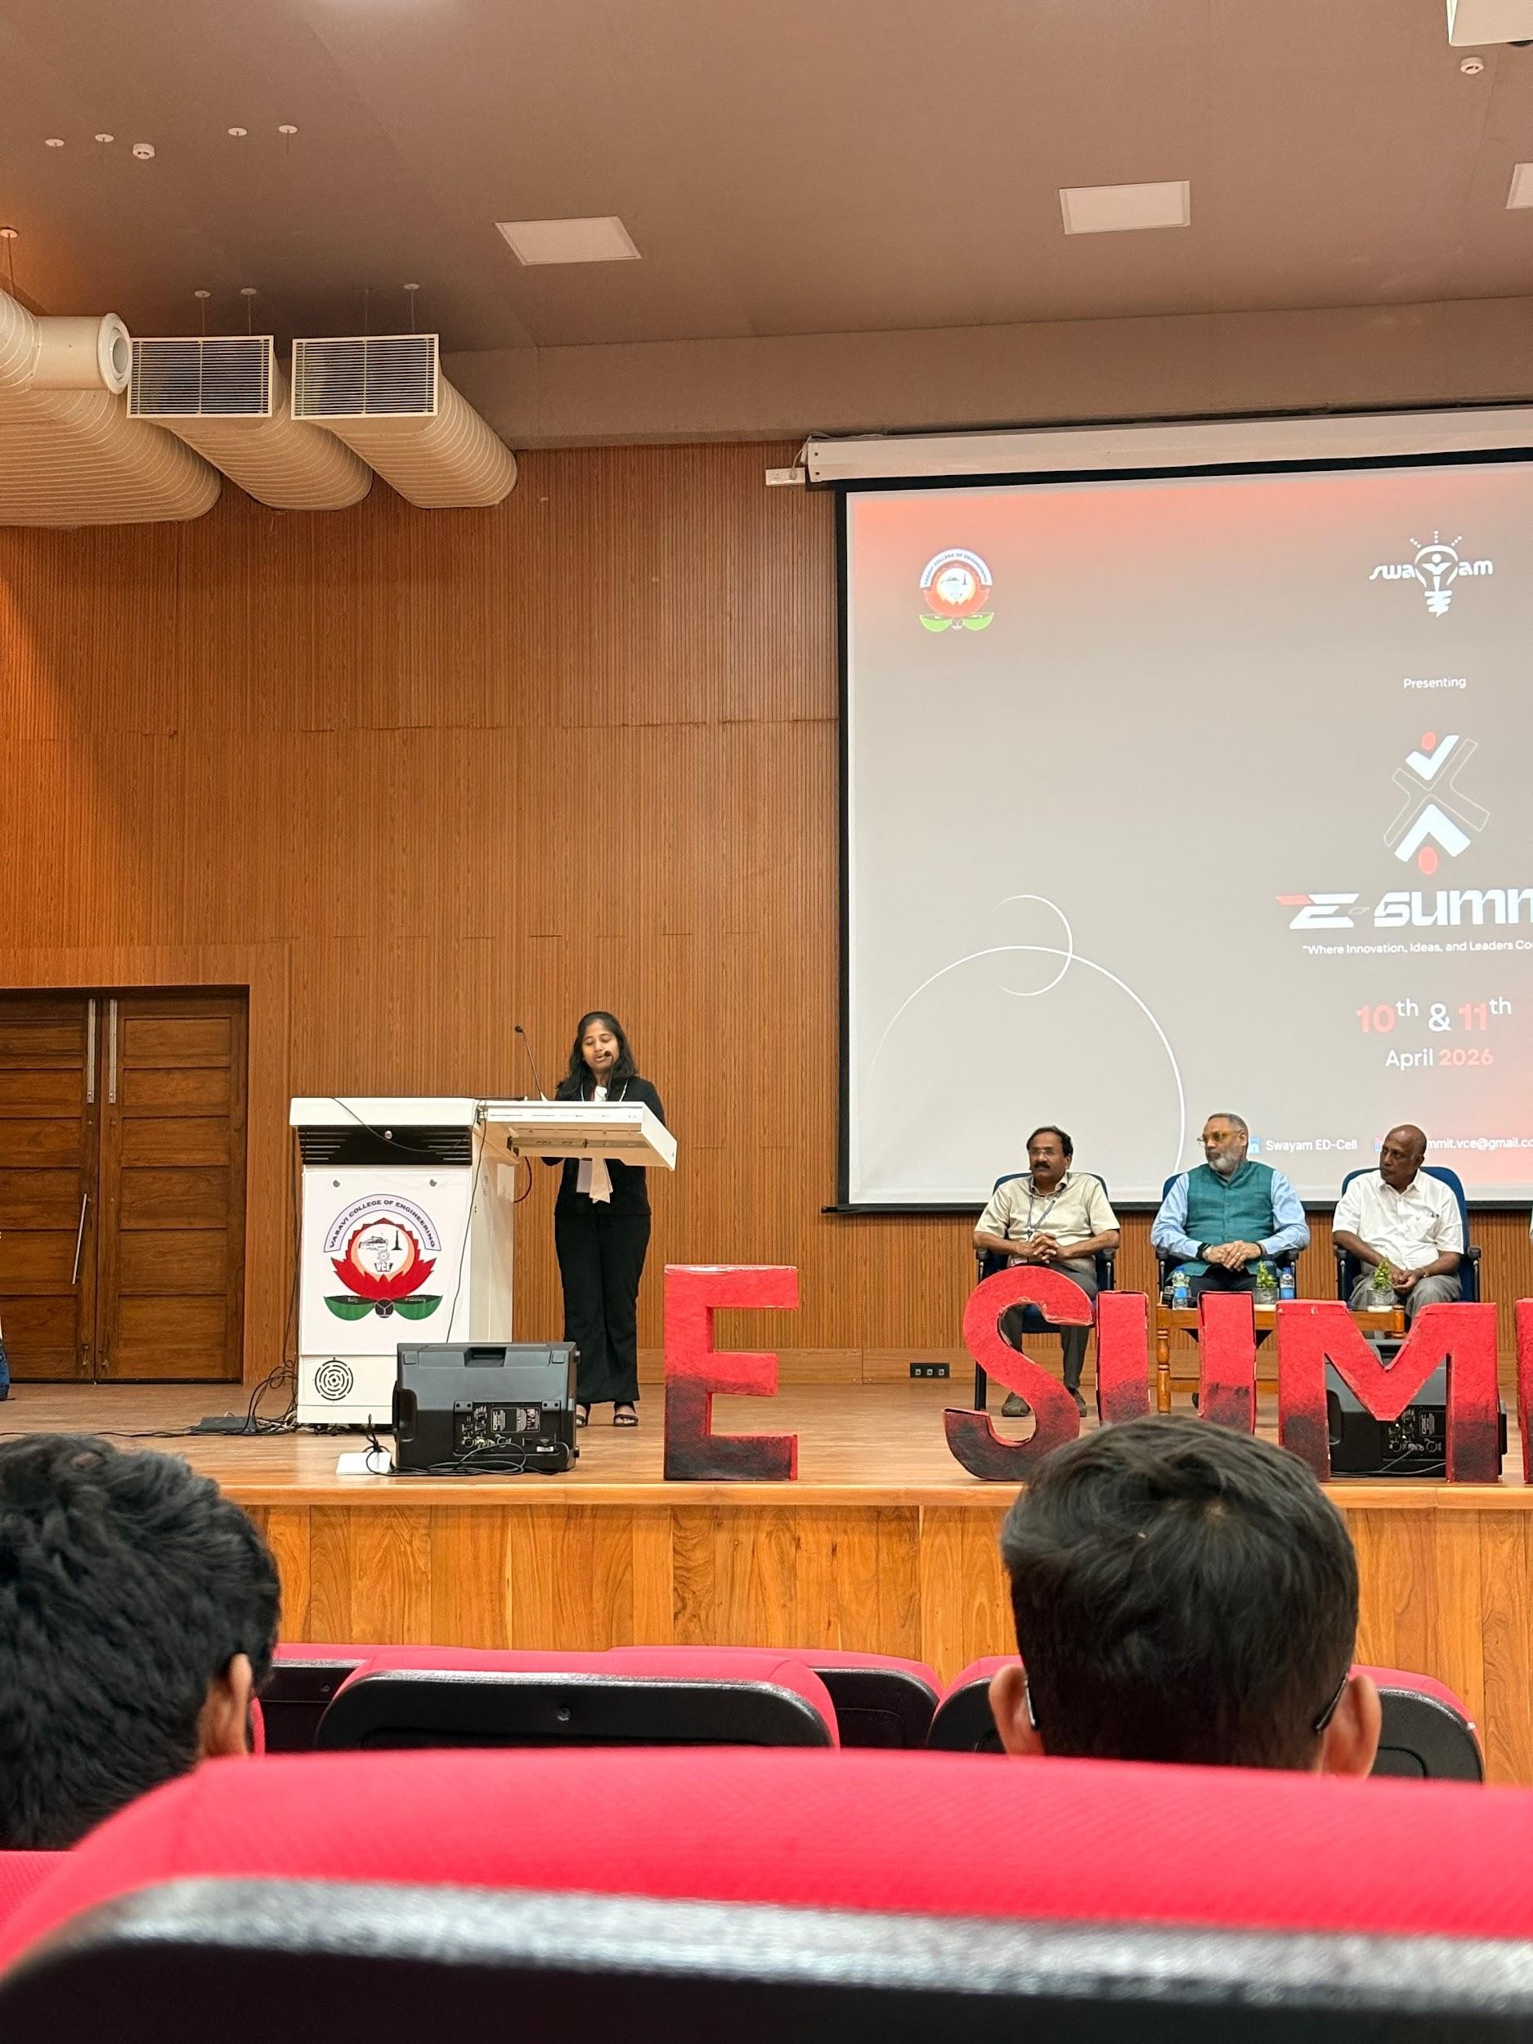

Participation Details :
- No. of Student Participants: 103
- No. of External Participants: 32
- No. of Faculty Participants: 4

Program Type :
Level 1 : Expert Talk / Exposure Visit / Exhibition / Mentoring Session
Level 2 : Conference / Seminar / Workshop / Competition / Exposure Visit
Level 3 : Boot Camp / Competition / Hackathon / Demo Day / Exhibition
Level 4 : Challenges / Competition / Hackathon / Tech-Fest / Boot Camp / Workshop / Exposure Visit / Exhibition / Demo Day

Programme Type / Domain
- IPR & Technology Transfer
- Innovation & Design Thinking
- Entrepreneurship & Startup
- Pre-incubation & Incubation Management
- Safe & Trusted AI
- Human Capital
- Science
- Resilience, Innovation & Efficiency
- Economic Growth & Social Good
- Democratizing AI Resources
- Inclusion for Social Empowerment

